Results of the MetOcean DWG PlugFest
Held at ECMWF, Reading, UK
On the 2nd October 2015

Stephan Siemen, Marie-Françoise Voidrot, Iain Russell,
Sören Kalesse, Daniel Lee, Alexander Bürger, … [please add your name after editing]

Table of Contents
Executive summary 1
Test Setup 1
WMS results sorted by clients 2
General observations 3
Improvements triggered by the plug fest 3
Diana 3
NinJo 4
VisualWeather 7
OnlineWeather 8
Leaflet.js 9
ArcGIS 10
Metview 10
WCS results sorted by clients 16
Rasdaman 16
QGis 2.10 17
List of participants 18
Appendix 1 – NinJo debug output 19

Executive summary
The Met Ocean Domain Working Group (DWG) held it latest plug fest at ECMWF as part of the Visualisation in Meteorology Week. For the first time not only Web Map Services (WMS) clients and servers were used, but also Web Coverages (Processing) Services (WC(P)S).
The tests using the WMS services and clients shown many improvements from last years plug fest at the EGOWS 2014 in Oslo. Less problems were found in the styling and overlaying of layers. Instead some access problems were observed which are related to access restrictions and security settings.
There was limited testing for the WC(P)S, but still some retrieved data could be visualised.

Test Setup
The plug fest was held in the Council Chamber at ECMWF. Represents of clients were situated at the table while represents of services went around the table and ensured their services were tested.

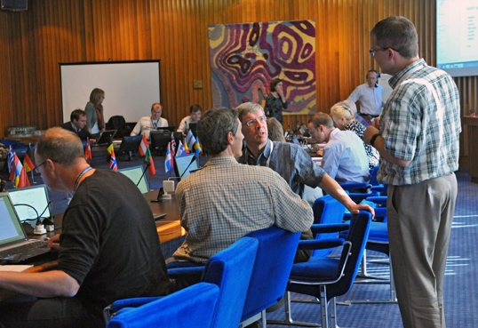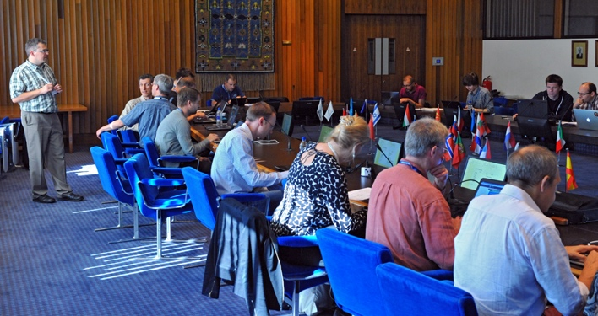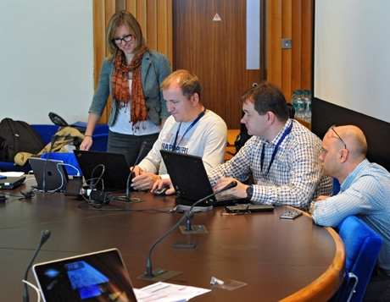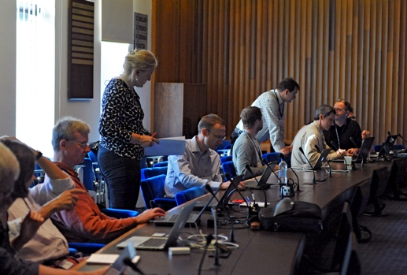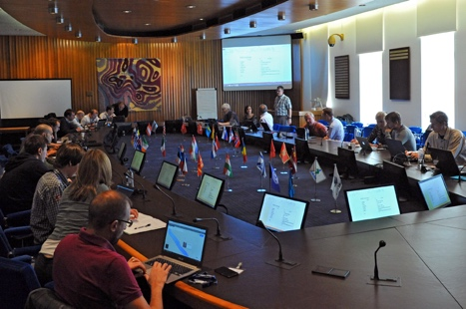
Figure 1 Photos from the event held in ECMWF’s Council Chamber.

WMS results sorted by clients
The WMS tests during the plug fest involved nine servers and clients. Table 1 gives the matrix of which combinations were tested and their outcome. Green fields indicate success, while red indicates failure to display a map in the client. Orange is reserved to indicate where

Servers | Clients
 | ADAGUC | GAIA | Diana | Metview | leafLet | ArcGIS | NinJo | IBL | QGIS
IBL | X MO | X | X² | X http not https | X | X | X | X | X
ECMWF |  | X | X² | X | X | X | X | X | X
DWD |  | X | X² | X¹ |  | X¹ | X¹ | X | X
NOAA |  |  |  | X | X
Météo France | X³ |  | X² | X⁴ |  | X | X | X | X
WOUDC |  |  |  | X |  |  | X
KNMI |  |  | X² | X⁵ | X |  | X | X | X
Norway |  |  |  |  |  |  |  | X
EUMETSAT | X |  |  | X |  |  | X | X | X

Table 1: Matrix of WMS test results between servers and clients.

Notes to Figure 1
- Some clients struggled to handle the authentication of the DWD server
- Diana: client side issues with bounding box calculation for some projections
- ADAGUC/MF pb to access server (ADAGUC pb?)
- Display in Metview was distorted because of a not well defined bounding box
- Metview could not load a particular layer because the default time dimension was invalid
LeafLet/ECMWF : error
Ninjo/MF : pb to parse getcapabilities
NINJO/KNMI : pb dimension with observation layers
NINJO/EUMETSAT: invalid parameter

General observations
In the following some general observations are noted.
- Users found that the naming of layers in EUMETview, the service provided by EUMETSAT, could be improved. Currently the user need expert knowledge to know what the layer contain.

Improvements triggered by the plug fest
Many issues identified during the plug fest were addressed either during or shortly after the plug fest. For example, Météo France updated their services shortly afterwards and offered them to the community for testing. Also the Diana could be improved during the plug fest.

Diana
Diana is an open source meteorological workstation software developed and used mainly by MET Norway and SMHI, but also at other institutes and companies.
Since version 3.39, Diana includes an alpha version of an WMS/WMTS/SlippyMap client. The version of the WMS client that was tested at the plugfest had problems with calculating bounding boxes for requests to WMS servers if the map projections of client and server do not match. This problem was known and is under investigation.

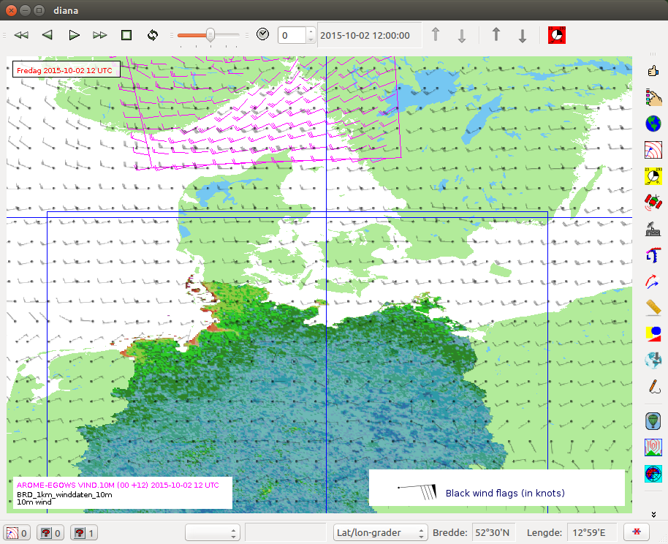
Figure 2 - Diana workstation overlaying layers served by ECMWF/eccharts (black wind arrows), DWD (filled), and
AROME MetCoop (MET Norway and SMHI, magenta wind arrows).
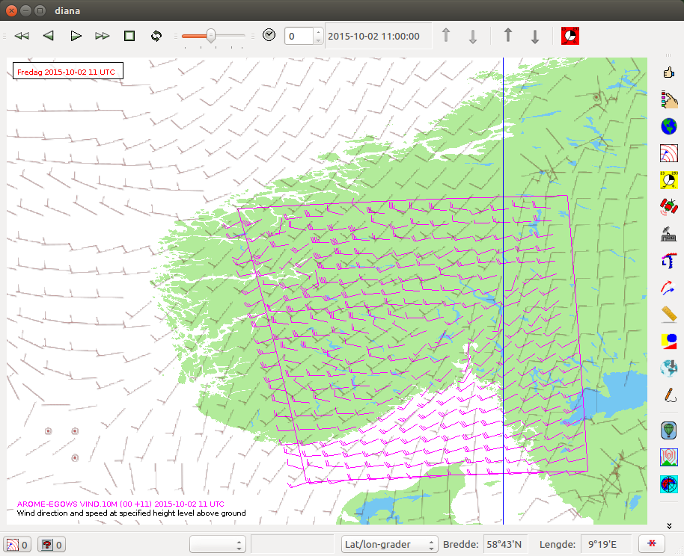
Figure 3 - Layers served by Météo France (grey wind arrows), and
AROME MetCoop (MET Norway and SMHI, magenta wind arrows).

NinJo
The NinJo forecaster workstation developed by a consortium of Germany, Switzerland, Denmark and Canada, offers since version 1.4 a WMS client.
The WMS client feels content-wise much improved since last year’s plugfest. With NinJo there were no problems with the content, but there were more problems with accessing the servers at all. For example there is a need to support HTTP authentication. The client was successful in visualizing WMS data from KNMI, ECMWF and IBL. The client was not able to visualize data from DWD, Météo-France and EUMETSAT’s EUMETview service.

Here’s a more detailed problem report for the servers that we couldn’t connect to:

DWD:

Server: http://maps.dwd.de/geoserver/wms?request=GetCapabilities&service=WMS&version=1.3.0

We got an exception, when accessing the server. Probably because the server uses HTTP authentication and NinJo does not support that.

Météo-France

We got an exception in the library that is used to contact the server (geo-tools library). The error happens in the parsing of the capabilities document.
During the plugfest we found out that the reason was a meta-data URL (attribute MetaDataUrl) in the French capabilities-document, which pointed to a server behind the firewall. It seems as if geo-tools library tries to resolve all URLs in the capabilities document.

KNMI:

The observation server did send a service exception.

The server returned an error when we tried to access the data. (Querying the capabilities worked fine). The error was also reported by somebody else (I just don’t remember who). We have until now no idea what caused this problem:

ERROR - <?xml version='1.0' encoding="ISO-8859-1" standalone="no" ?>
<!DOCTYPE ServiceExceptionReport SYSTEM "http://schemas.opengis.net/wms/1.1.1/exception_1_1_1.dtd">
<ServiceExceptionReport version="1.1.1">
<ServiceException>
Invalid dimension value for layer cloud_area_fraction;
No results for query: 'hidden';
Unable to fill in dimensions;
WMS GetMap Request failed;
</ServiceException>
</ServiceExceptionReport>

EUMETSAT:

Server: http://eumetview.eumetsat.int/geoserver/wms?service=wms&version=1.3.0&request=GetCapabilities

The server complains that the request for capabilities is invalid. We had no to time to figure out exactly why it didn’t like the request. This was the error:

ERROR - <ows:ExceptionReport xmlns:xs="http://www.w3.org/2001/XMLSchema" xmlns:ows="http://www.opengis.net/ows" xmlns:xsi="http://www.w3.org/2001/XMLSchema-instance" version="1.0.0" xsi:schemaLocation="http://www.opengis.net/ows http://eumetview.eumetsat.int:80/geoserv/schemas/ows/1.0.0/owsExceptionReport.xsd">
<ows:Exception exceptionCode="InvalidParameterValue" locator="service">
<ows:ExceptionText>Single value expected for request parameter service but instead found: [wms, WMS]</ows:ExceptionText>
</ows:Exception>
</ows:ExceptionReport>
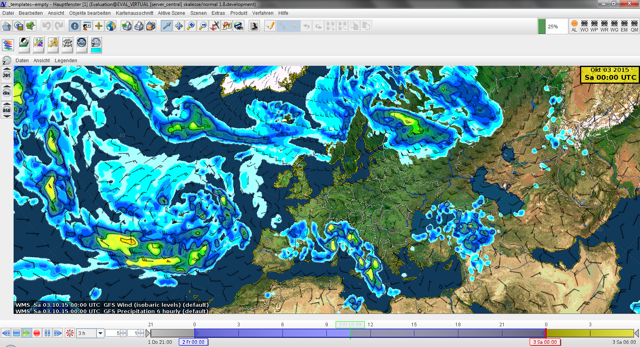
Figure 5 - NinJo client showing layers served by IBL WMS server.
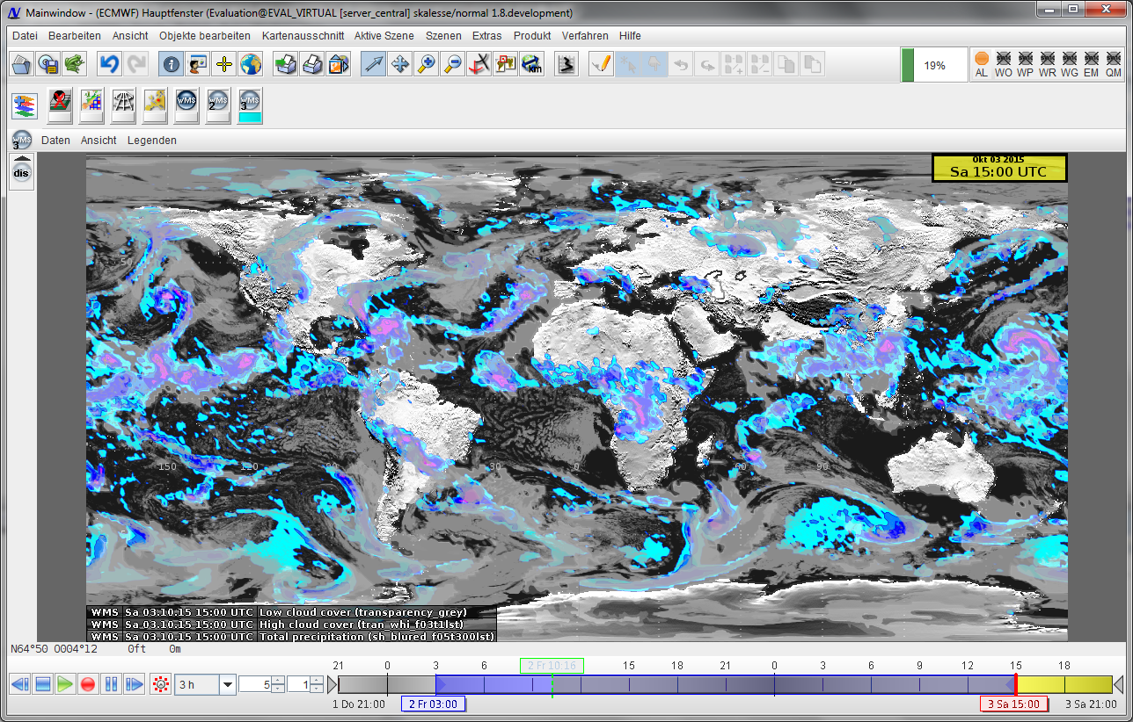
Figure 6 - Layers served by ecCharts/ECMWF shown in NinJo.
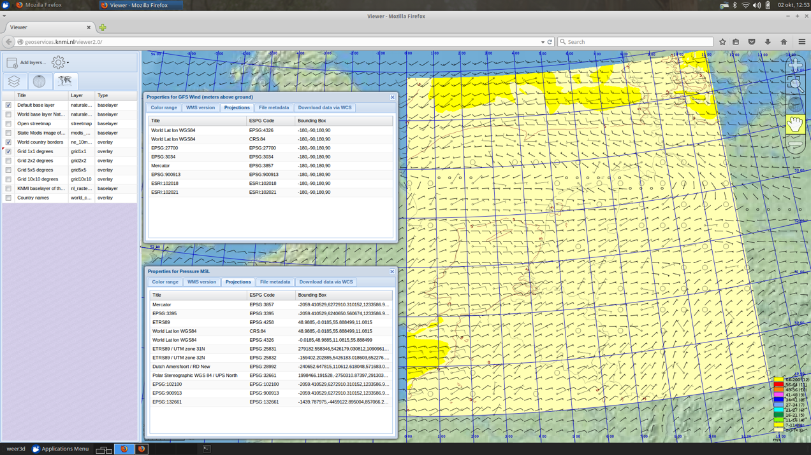
Figure 7 - NinJo client showing layers from the models GFS (IBL) and Harmonie (KNMI).
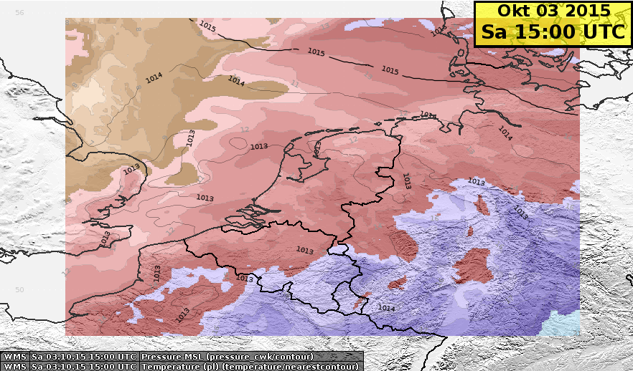
Figure 8 - KNMI WMS layers shown in NinJo.

VisualWeather
Figure 9 - VisualWeather showing satellite layers from EUMETview and wind from the GFS service from IBL.
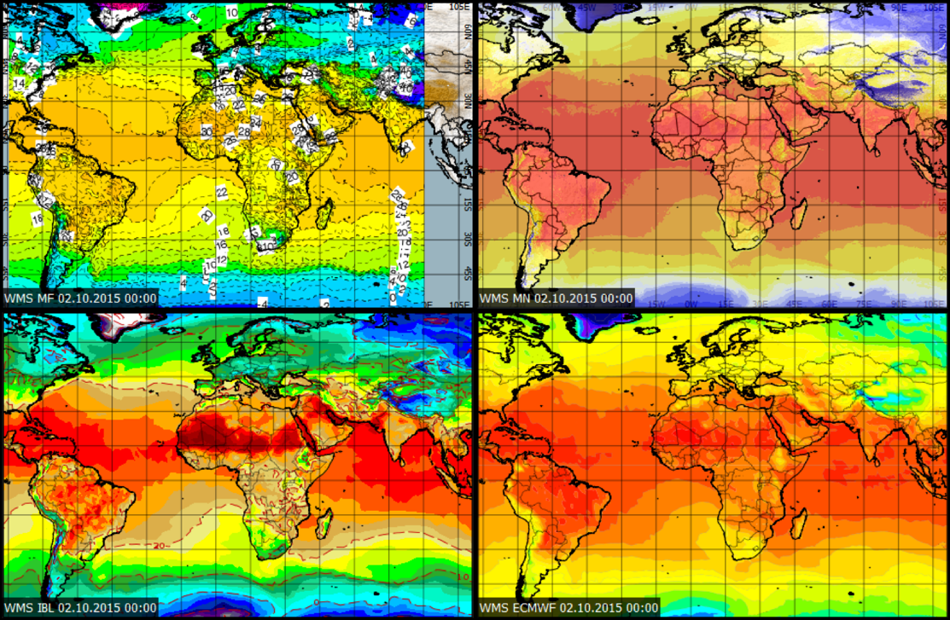
Figure 10 - VisualWeather showing surface temperature from four WMS services. Clock-wise from the top left they are: Météo France, ECMWF, MET Norway and IBL-GFS.

OnlineWeather

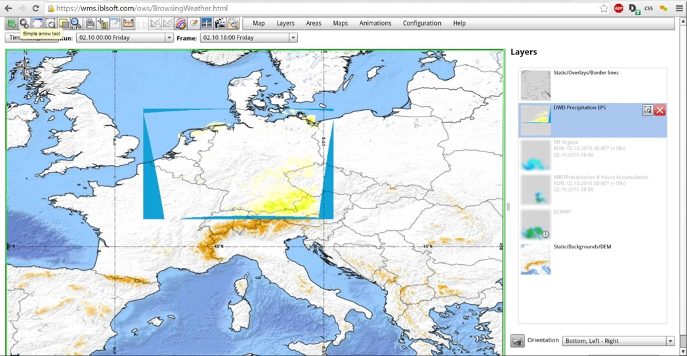
Figure 11 - OnlineWeather showing WMS layers from DWD.
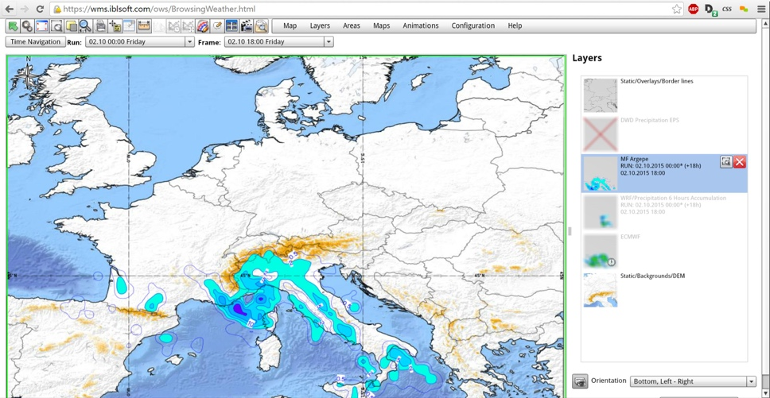
Figure 12 - OnlineWeather showing precipitation forecasts from Météo France.
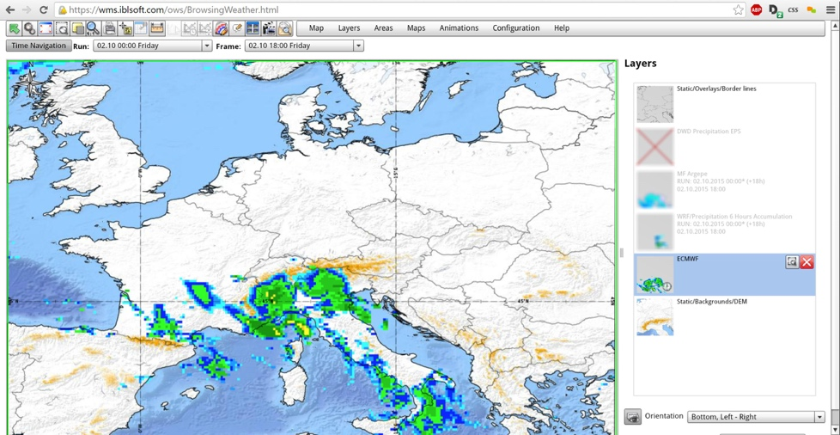
Figure 13 - OnlineWeather showing precipitation forecasts from ECMWF.

Leaflet.js
The leaflet JavaScript web mapping web framework is a non-domain specific client which was kindly tested by

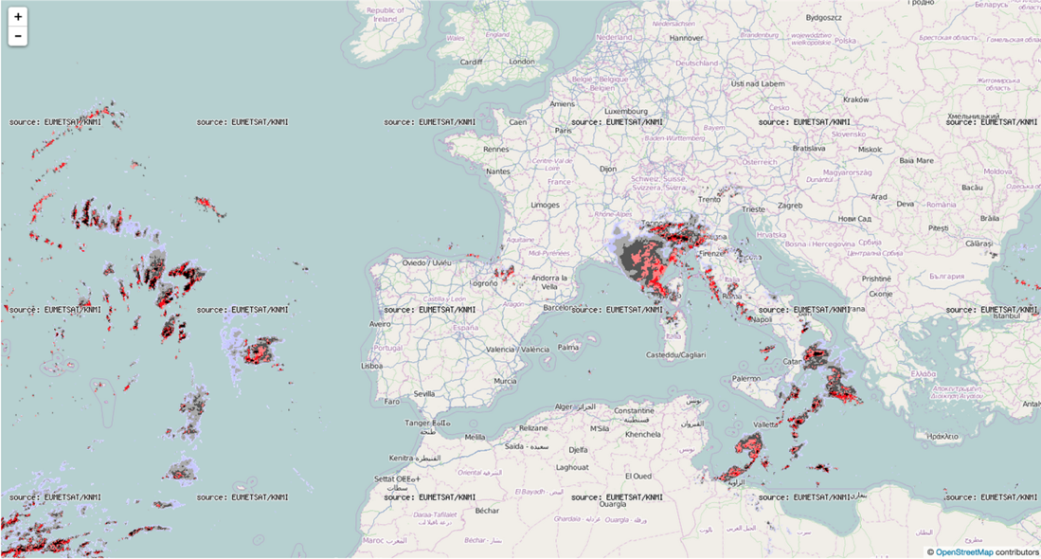
Figure 14 - Leaflet.js showing satellite overlay of Harmony KNMI field.

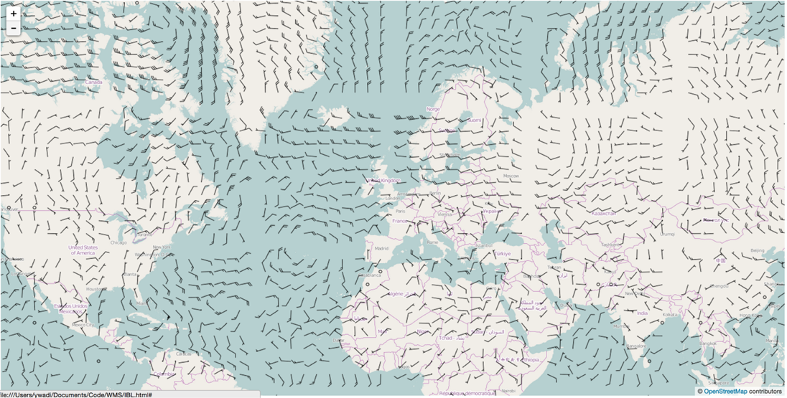
Figure 15 - Leaflet showing GFS 10m wind field served by the server from IBL.

ArcGIS

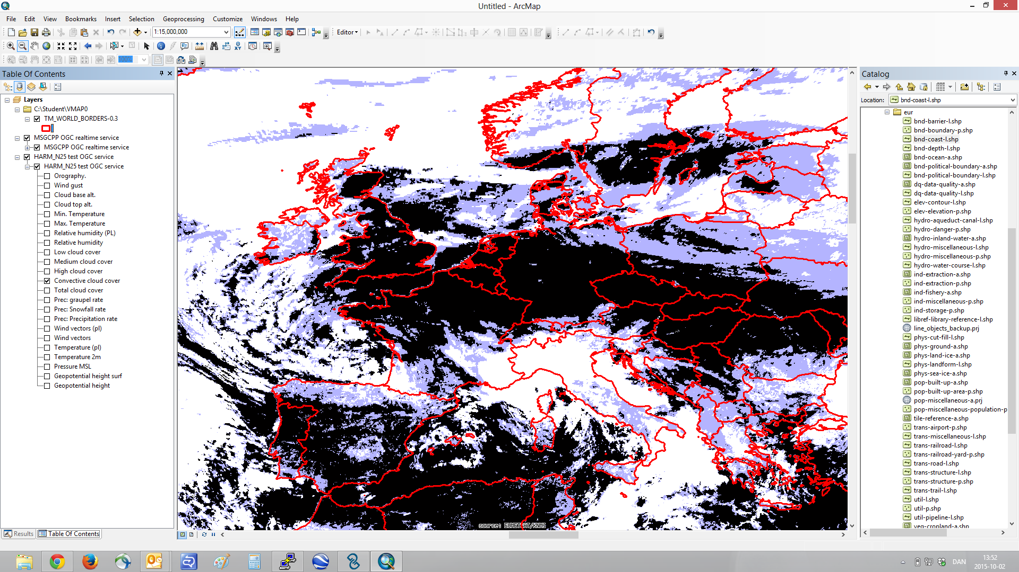
Figure 16 - Satellite layer served by KNMI in ArcGIS.

Metview
This WMS client is developed as part of ECMWF’s Metview workstation. The client lets users browse the available layers retrieved from the GetCapabilities document. Meta data including the legend is displayed at a side panel on the right. An additional panel allows entry of settings for various dimensions.
Metview could not connect to DWD’s service because of its use of https and user login.

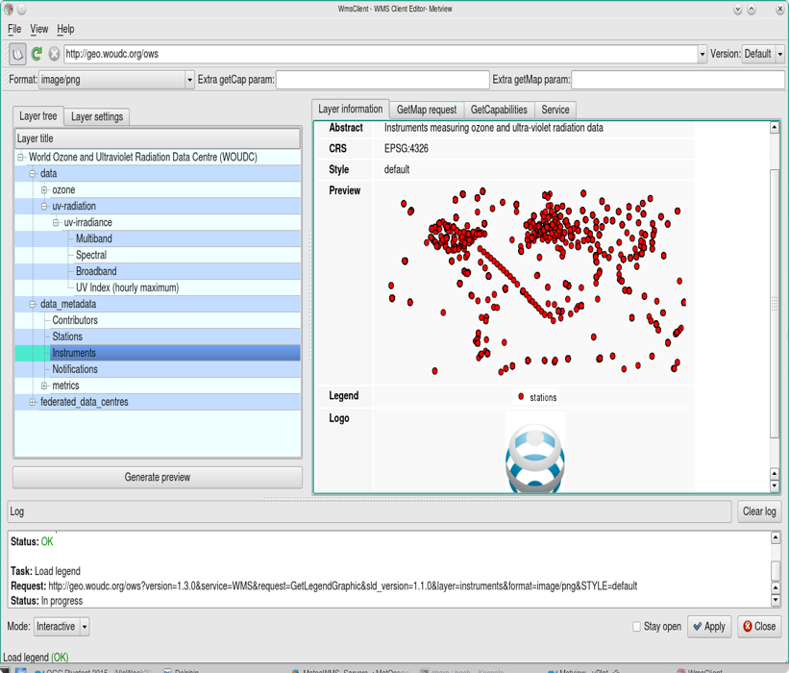
Figure 17- Metview showing the getCapabilities returned by Environment Canada. Layers are shown on the left, on the right a preview is shown. The layer we selected made it hard to check whether it was correctly geolocated, but it seemed plausible.
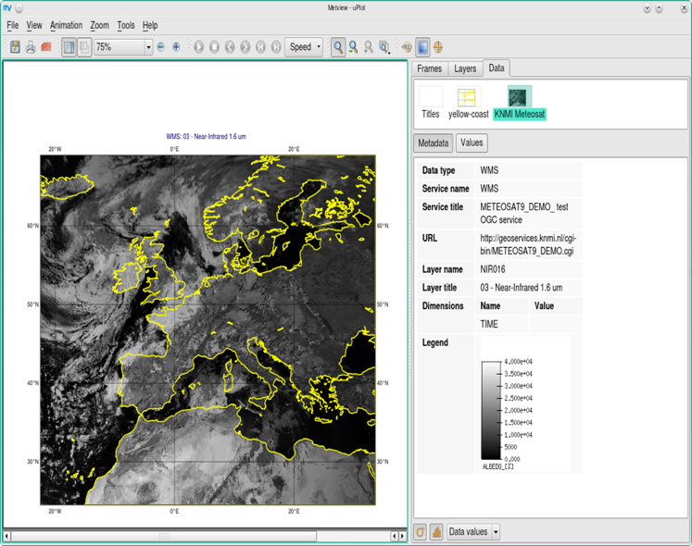
Figure 18 - Metview showing a satellite layer served from the KNMI server, with layer information displayed on the right. The alignment with Metview’s own coastlines was perfect.

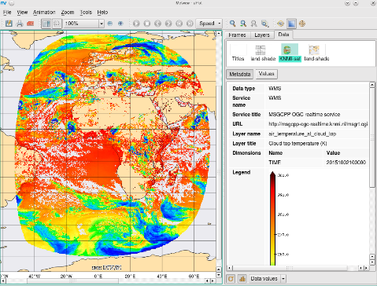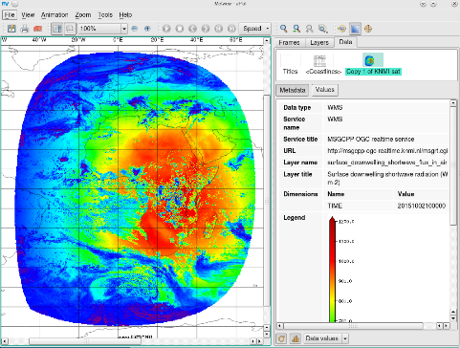
Figure 19 – Metview showing more satellite data from KNMI. This was harder to verify but it looked like it matched the coastlines well.

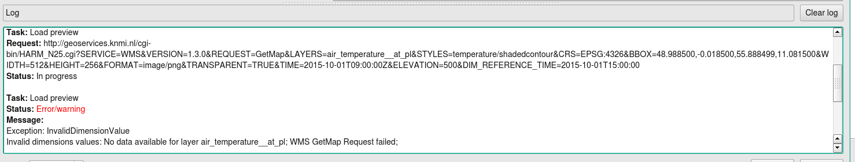
Figure 20 – Metview could not retrieve the air temperature layer from KNMI’s HARMONIE server when using the default time dimensions. These were invalid, with the default TIME being before the default reference time. With manually-specified times it was ok.

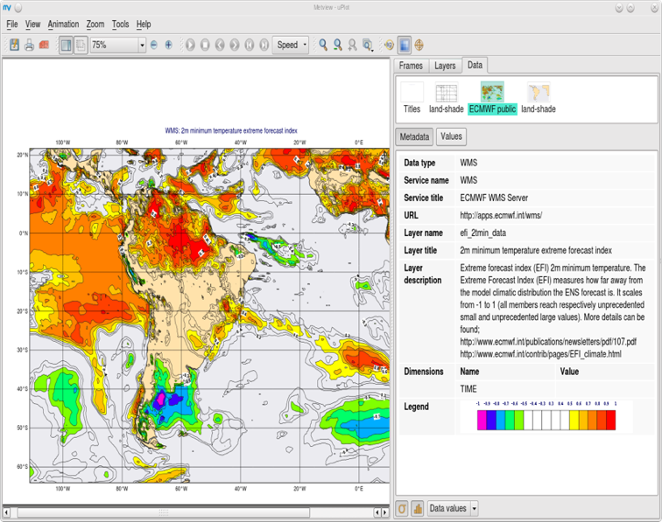
Figure 21 - Metview showing a layer served by ECMWF's ecCharts/WMS service. Layer information is displayed on the right.
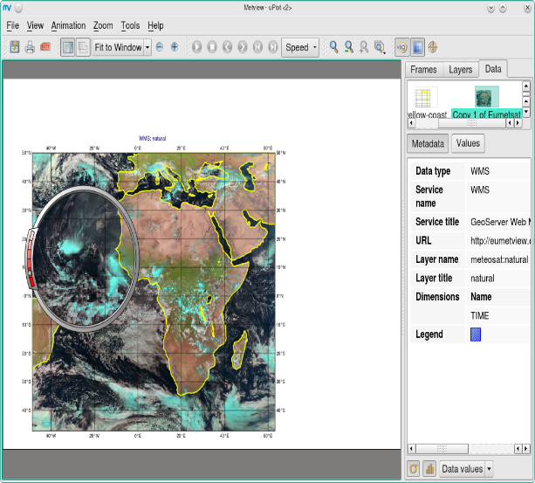
Figure 22- Metview showing data from the EUMETSAT server, looks correct.
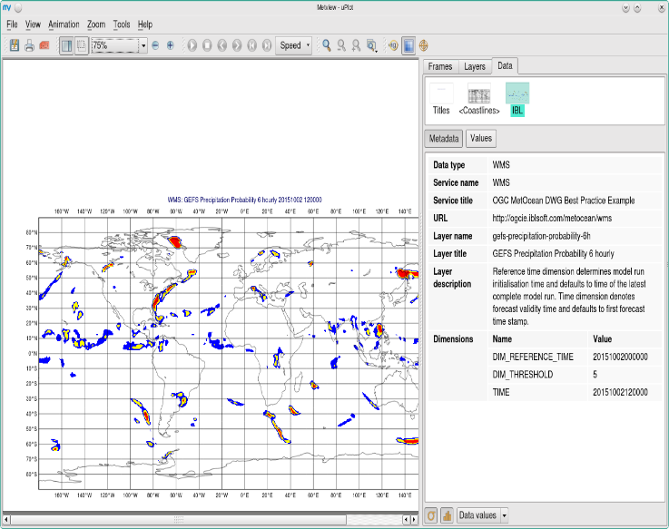
Figure 23 – Metview showing a later from IBL’s server. Metview could not connect to this server through https, but http worked. The problem seemed to be on Metview’s side.

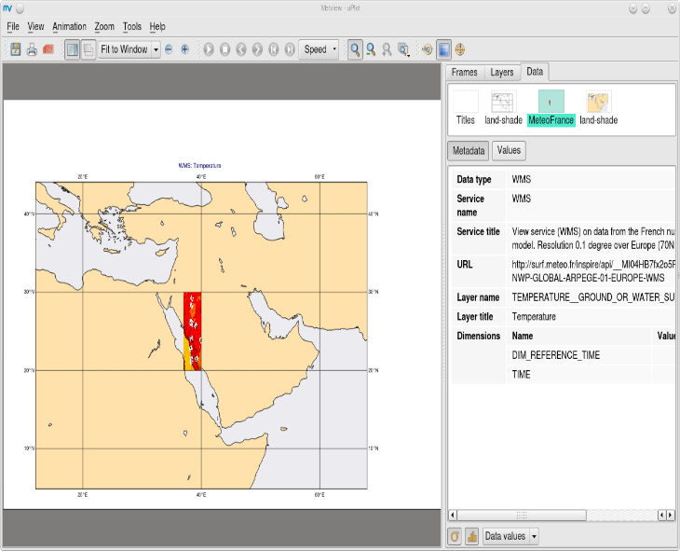
Figure 24 - Metview showing a later from Météo France’s Arpege 0.1 service, using WMS 1.3.0. Metview did not request a specific area. The returned minx,maxX etc coordinates seemed to be wrong.

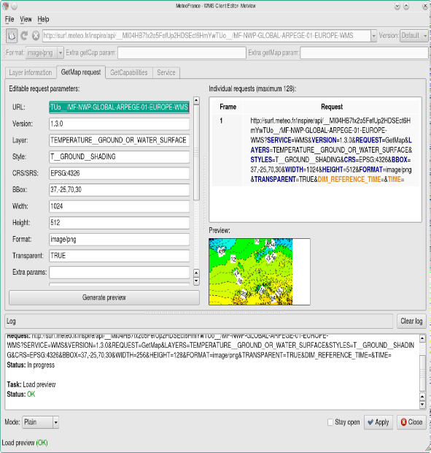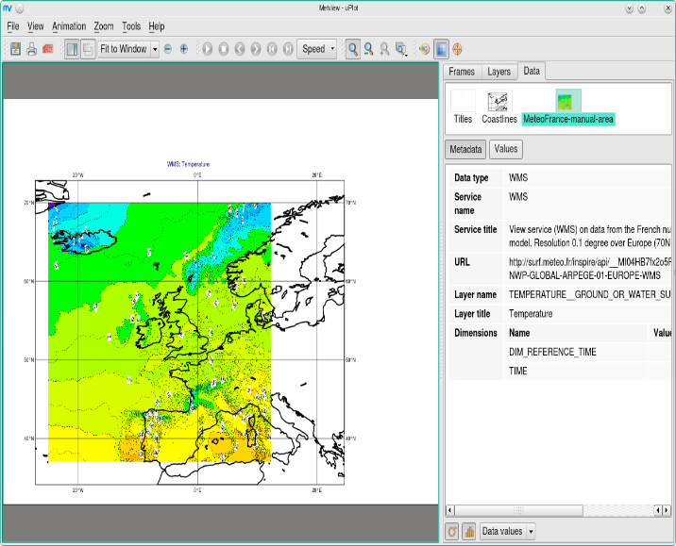
Figure 25 – Metview with Météo France again. We tried to swap the coordinates (x with y) but the resulting plot, although better, was shifted.

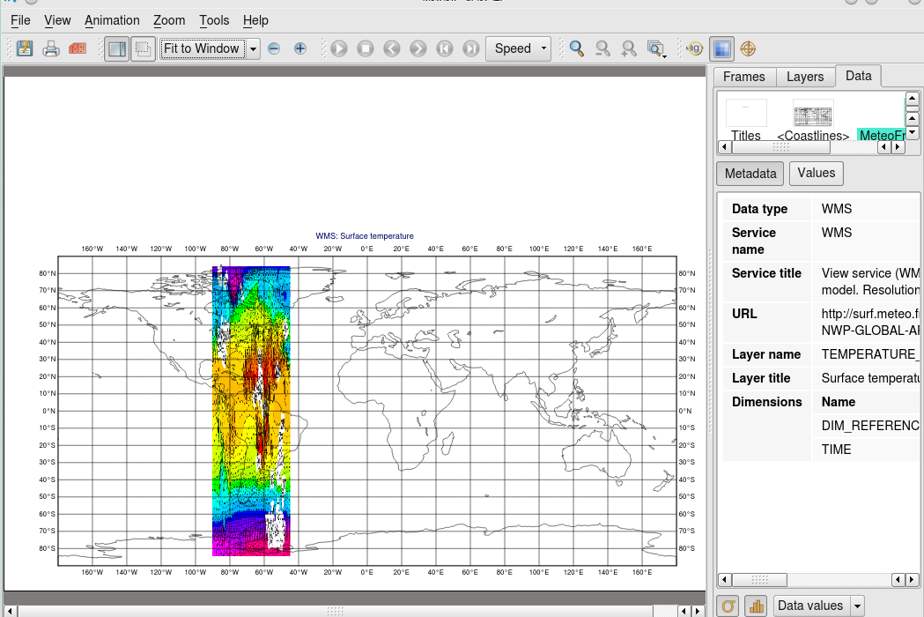
Figure 26 – Metview showing a layer from Météo France’s Arpege 0.5 service. The scaling seemed quite wrong.

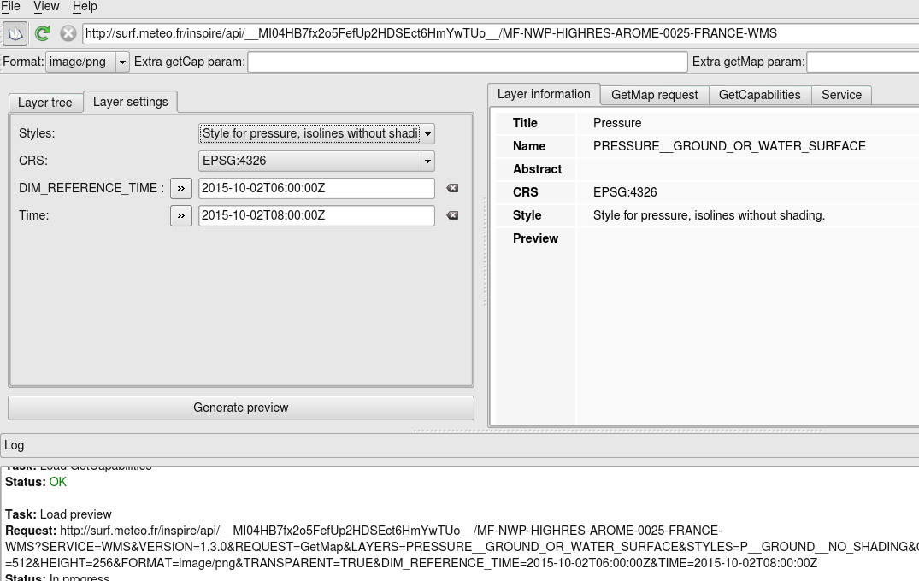
Figure 27 – Metview attempting to plot a layer from Météo France’s Arome server. The layers seemed to be blank.

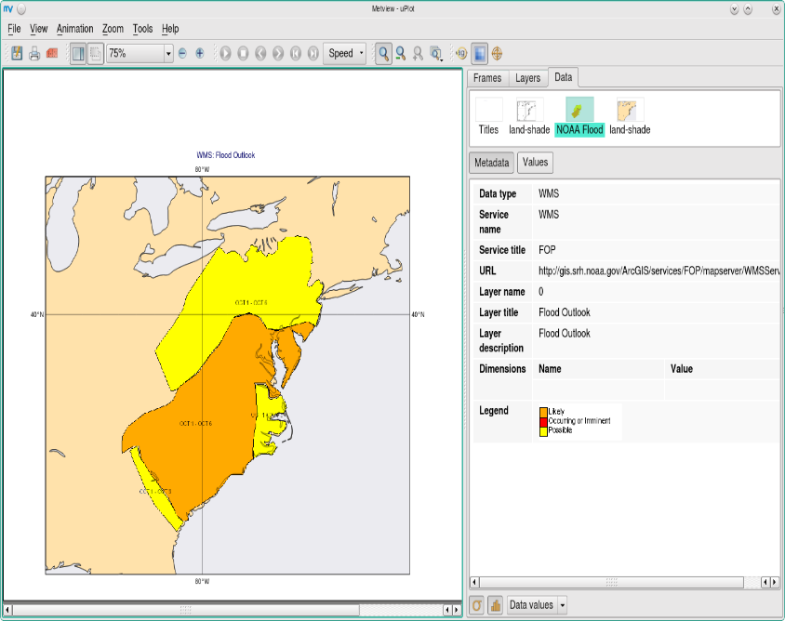
Figure 28 – Metview displaying a layer from NOAA. It seemed to be located correctly.

WCS results sorted by clients
This was the first WCS server and client took part in the plug fest.

Servers | Clients
 | QGIS | Rasdaman WCS Client | Rasdaman WCPS | NASA World Wind
IBL | X
Rasdaman |  | X | X | X
Météo France |  | X | X | X
Table 2: Test matrix for WCS services and clients.

WCS Rasdaman * to MF server: not directly but through rasdaman servers

Rasdaman
The rasdaman software is developed by the rasadaman GmBH in Bremen and participated through the EarthServer2 project ECMWF is part of.

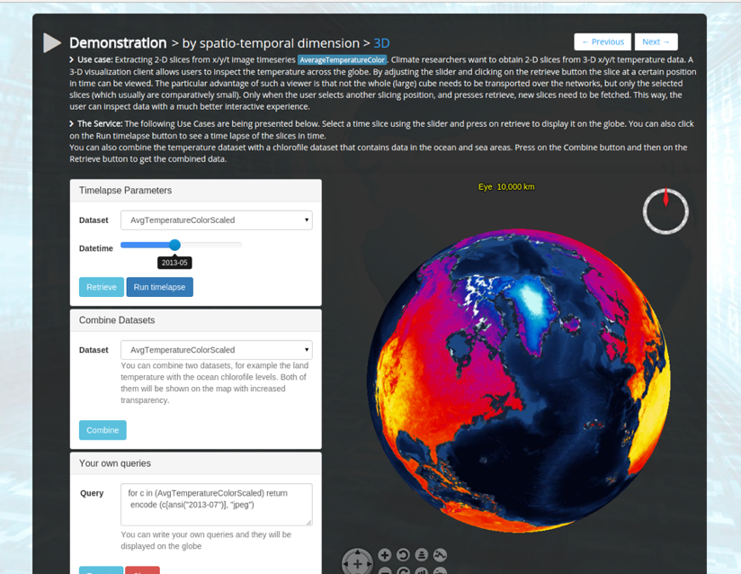
Figure 29 - NASA WorldWind showing data served by the rasdaman WCS.
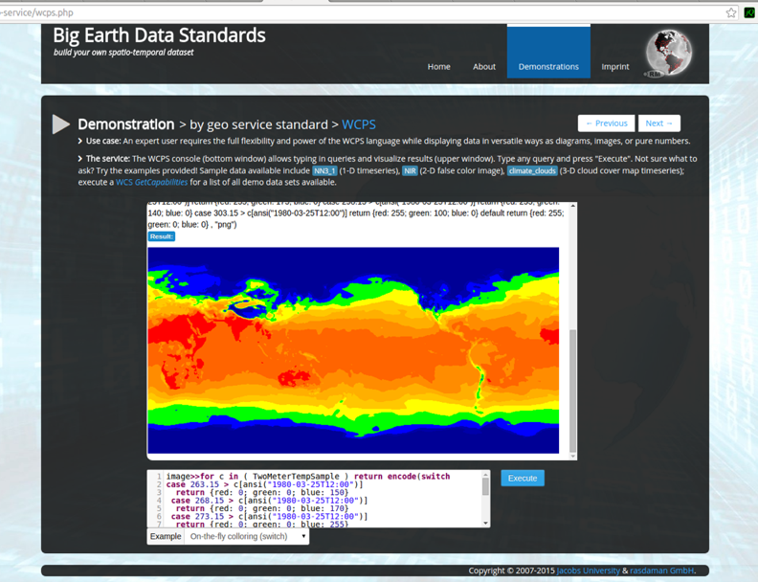
Figure 30 - rasdaman WCS client showing data served by ECMWF.
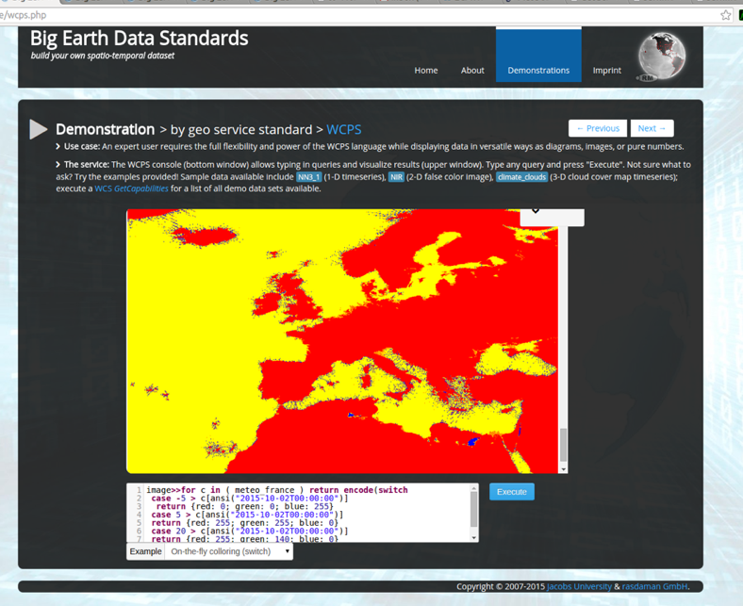
Figure 31 - Rasdaman client showing Météo France data served through WCS redirected through a rasdaman server.

QGis 2.10

https://ogcie.iblsoft.com/ncep/gfs?VERSION=1.0.0&request=GetCapabilities
- ssl warning (self-signed cert?)
- Also does not get any layers to the list from get capabilities, unknown reason

http://surf.meteo.fr/inspire/api/__MI04HB7fx2o5FefUp2HDSEct6HmYwTUo__/MF-NWP-GLOBAL-ARPEGE-01-EUROPE-WCS?SERVICE=WCS&REQUEST=GetCapabilities&version=2.0.1
- Because of QGIS not supporting 2.0.1 ?

Could not understand the response:
Download of capabilities failed: Error downloading http://incubator.ecmwf.int/2d/rasdaman/ows?SERVICE=WCS&REQUEST=GetCapabilities&AcceptVersions=1.1.0,1.0.0 - server replied: Bad Request
- Because of QGIS not supporting 2.0.1 ?

Could not understand the response:
Download of capabilities failed: Error downloading http://flanche.com:9090/rasdaman/ows?SERVICE=WCS&REQUEST=GetCapabilities&AcceptVersions=1.1.0,1.0.0 - server replied: Bad Request
- Because of QGIS not supporting 2.0.1

List of participants

Name | Organisation | Involvement
Jozef Matula | IBL | VisualWeather, OnlineWeather, OpenWeather
Michal Weis | IBL | VisualWeather, OnlineWeather, OpenWeather, WMS & WCS
Martin Franek | IBL | VisualWeather, OnlineWeather, OpenWeather
Stephane Dekeyzer | IRM-KMI Belgium
Sören Kalesse | DWD | NinJo WMS client layer
Daniel Lee | DWD | QGis as WMS client
Yousef Wadi | Arabia Weather Inc. | Leaflet.js as WMS client
Mikko Visa | FMI | QGis as WMS and WCS client
Iain Russell | ECMWF | Metview as WMS client
Sandor Kertesz | ECMWF | Metview as WMS client
Carlos Valiente | ECMWF | ecCharts WMS server
Vlad Merticariu | Jacobs University Bremen | Rasdaman WC(P)S server & EarthServer clients
Julia Wagemann | ECMWF | Rasdaman WC(P)S server & EarthServer clients
Marc Rautenhaus | Technical University Munich
Ernst de Vreede | KNMI | ADAGUC as WMS client
Michal Koutek | KNMI | ADAGUC as WMS client
Alexandro Coque | Vestas | ArcGIS as WMS client
Alexander Bürger | MET Norway | Diana as a WMS client
Marie-Francoise Voidrot | Météo France | Event co-ordinator
Jürgen Seib | DWD | DWD WMS server
Rémy Giraud | Météo France | Météo France WMS & WCS servers
Gabrielle Kaufmann | Météo France | Météo France WMS & WCS servers
Chris Little | UK Met Office | Event co-ordinator
Stephan Siemen | ECMWF | Event co-ordinator

Appendix 1 – NinJo debug output

DEBUG INFO:

ent=true'>http://geoservices.knmi.nl/cgi-bin/HARM_N25.cgi?SERVICE=WMS&&version=1.1.1&service=WMS&request=GetLegendGraphic&layer=wind__at_10m&format=image/png&STYLE=Windbarbs_kts/thinbarbshaded&layers=wind__at_10m&&time=2015-10-02T03%3A00%3A00Z&DIM_reference_time=2015-10-01T12%3A00%3A00&&transparent=true

GetMap:

http://geoservices.knmi.nl/cgi-bin/bgmaps.cgi?SERVICE=WMS&&SERVICE=WMS&VERSION=1.1.1&REQUEST=GetMap&LAYERS=naturalearth2&WIDTH=1095&HEIGHT=930&SRS=EPSG%3A32661&BBOX=1875747.771394944,-2807085.247069953,3033107.9582088734,-1824121.8007348347&STYLES=&FORMAT=image/gif&TRANSPARENT=TRUE&

http://geoservices.knmi.nl/cgi-bin/HARM_N25.cgi?SERVICE=WMS&&SERVICE=WMS&VERSION=1.3.0&REQUEST=GetMap&LAYERS=wind__at_10m&WIDTH=1095&HEIGHT=930&CRS=EPSG%3A32661&BBOX=1875747.771394944,-2807085.247069953,3033107.9582088734,-1824121.8007348347&STYLES=Windbarbs_kts%2Fthinbarbshaded&FORMAT=image/png&TRANSPARENT=TRUE&&time=2015-10-02T03%3A00%3A00Z&DIM_reference_time=2015-10-01T12%3A00%3A00

https://ogcie.iblsoft.com/metocean/wms?&SERVICE=WMS&VERSION=1.3.0&REQUEST=GetMap&LAYERS=gfs-wind-agl&WIDTH=1095&HEIGHT=930&CRS=EPSG%3A32661&BBOX=1875747.771394944,-2807085.247069953,3033107.9582088734,-1824121.8007348347&STYLES=default&FORMAT=image/png&TRANSPARENT=TRUE&&DIM_reference_time=2015-10-01T12%3A00%3A00Z&elevation=10&time=2015-10-02T03%3A00%3A00Z

http://geoservices.knmi.nl/cgi-bin/worldmaps.cgi?&SERVICE=WMS&VERSION=1.1.1&REQUEST=GetMap&LAYERS=ne_10m_admin_0_countries_simplified&WIDTH=1095&HEIGHT=930&SRS=EPSG%3A32661&BBOX=1875747.771394944,-2807085.247069953,3033107.9582088734,-1824121.8007348347&STYLES=&FORMAT=image/png&TRANSPARENT=TRUE&

WMJSLayer::setStyle: Windspeed/contour

GetMap:

http://geoservices.knmi.nl/cgi-bin/HARM_N25.cgi?SERVICE=WMS&&SERVICE=WMS&VERSION=1.3.0&REQUEST=GetMap&LAYERS=wind__at_10m&WIDTH=1095&HEIGHT=930&CRS=EPSG%3A32661&BBOX=1875747.771394944,-2807085.247069953,3033107.9582088734,-1824121.8007348347&STYLES=Windspeed%2Fcontour&FORMAT=image/png&TRANSPARENT=TRUE&&time=2015-10-02T03%3A00%3A00Z&DIM_reference_time=2015-10-01T12%3A00%3A00

GetLegendGraphic:

http://geoservices.knmi.nl/cgi-bin/HARM_N25.cgi?SERVICE=WMS&&version=1.1.1&service=WMS&request=GetLegendGraphic&layer=wind__at_10m&format=image/png&STYLE=Windspeed/contour&layers=wind__at_10m&&time=2015-10-02T03%3A00%3A00Z&DIM_reference_time=2015-10-01T12%3A00%3A00&&transparent=true

WMJSLayer::setStyle: Windbarbs_kts/barbshadedcontour

GetMap:

http://geoservices.knmi.nl/cgi-bin/HARM_N25.cgi?SERVICE=WMS&&SERVICE=WMS&VERSION=1.3.0&REQUEST=GetMap&LAYERS=wind__at_10m&WIDTH=1095&HEIGHT=930&CRS=EPSG%3A32661&BBOX=1875747.771394944,-2807085.247069953,3033107.9582088734,-1824121.8007348347&STYLES=Windbarbs_kts%2Fbarbshadedcontour&FORMAT=image/png&TRANSPARENT=TRUE&&time=2015-10-02T03%3A00%3A00Z&DIM_reference_time=2015-10-01T12%3A00%3A00

GetLegendGraphic:

http://geoservices.knmi.nl/cgi-bin/HARM_N25.cgi?SERVICE=WMS&&version=1.1.1&service=WMS&request=GetLegendGraphic&layer=wind__at_10m&format=image/png&STYLE=Windbarbs_kts/barbshadedcontour&layers=wind__at_10m&&time=2015-10-02T03%3A00%3A00Z&DIM_reference_time=2015-10-01T12%3A00%3A00&&transparent=true

GetMap:

http://geoservices.knmi.nl/cgi-bin/HARM_N25.cgi?SERVICE=WMS&&SERVICE=WMS&VERSION=1.3.0&REQUEST=GetMap&LAYERS=wind__at_10m&WIDTH=1095&HEIGHT=930&CRS=EPSG%3A32661&BBOX=1875747.771394944,-2807085.247069953,3033107.9582088734,-1824121.8007348347&STYLES=Windbarbs_kts%2Fbarbshadedcontour&FORMAT=image/png&TRANSPARENT=TRUE&&time=2015-10-02T03%3A00%3A00Z&DIM_reference_time=2015-10-01T12%3A00%3A00&COLORSCALERANGE=0,100

GetLegendGraphic:

http://geoservices.knmi.nl/cgi-bin/HARM_N25.cgi?SERVICE=WMS&&version=1.1.1&service=WMS&request=GetLegendGraphic&layer=wind__at_10m&format=image/png&STYLE=Windbarbs_kts/barbshadedcontour&layers=wind__at_10m&&time=2015-10-02T03%3A00%3A00Z&DIM_reference_time=2015-10-01T12%3A00%3A00&&COLORSCALERANGE=0,100&transparent=true

GetMap:

http://geoservices.knmi.nl/cgi-bin/bgmaps.cgi?SERVICE=WMS&&SERVICE=WMS&VERSION=1.1.1&REQUEST=GetMap&LAYERS=naturalearth2&WIDTH=1585&HEIGHT=931&SRS=EPSG%3A32661&BBOX=1617694.7485606833,-2807085.2470699525,3291160.9810431344,-1824121.8007348347&STYLES=&FORMAT=image/gif&TRANSPARENT=TRUE&

http://geoservices.knmi.nl/cgi-bin/HARM_N25.cgi?SERVICE=WMS&&SERVICE=WMS&VERSION=1.3.0&REQUEST=GetMap&LAYERS=wind__at_10m&WIDTH=1585&HEIGHT=931&CRS=EPSG%3A32661&BBOX=1617694.7485606833,-2807085.2470699525,3291160.9810431344,-1824121.8007348347&STYLES=Windbarbs_kts%2Fbarbshadedcontour&FORMAT=image/png&TRANSPARENT=TRUE&&time=2015-10-02T03%3A00%3A00Z&DIM_reference_time=2015-10-01T12%3A00%3A00

https://ogcie.iblsoft.com/metocean/wms?&SERVICE=WMS&VERSION=1.3.0&REQUEST=GetMap&LAYERS=gfs-wind-agl&WIDTH=1585&HEIGHT=931&CRS=EPSG%3A32661&BBOX=1617694.7485606833,-2807085.2470699525,3291160.9810431344,-1824121.8007348347&STYLES=default&FORMAT=image/png&TRANSPARENT=TRUE&&DIM_reference_time=2015-10-01T12%3A00%3A00Z&elevation=10&time=2015-10-02T03%3A00%3A00Z

http://geoservices.knmi.nl/cgi-bin/worldmaps.cgi?&SERVICE=WMS&VERSION=1.1.1&REQUEST=GetMap&LAYERS=ne_10m_admin_0_countries_simplified&WIDTH=1585&HEIGHT=931&SRS=EPSG%3A32661&BBOX=1617694.7485606833,-2807085.2470699525,3291160.9810431344,-1824121.8007348347&STYLES=&FORMAT=image/png&TRANSPARENT=TRUE&

GetMap:

http://geoservices.knmi.nl/cgi-bin/bgmaps.cgi?SERVICE=WMS&&SERVICE=WMS&VERSION=1.1.1&REQUEST=GetMap&LAYERS=naturalearth2&WIDTH=1585&HEIGHT=931&SRS=EPSG%3A32661&BBOX=1336848.0496077924,-2813420.135016259,3010314.2820902434,-1830456.6886811408&STYLES=&FORMAT=image/gif&TRANSPARENT=TRUE&

http://geoservices.knmi.nl/cgi-bin/HARM_N25.cgi?SERVICE=WMS&&SERVICE=WMS&VERSION=1.3.0&REQUEST=GetMap&LAYERS=wind__at_10m&WIDTH=1585&HEIGHT=931&CRS=EPSG%3A32661&BBOX=1336848.0496077924,-2813420.135016259,3010314.2820902434,-1830456.6886811408&STYLES=Windbarbs_kts%2Fbarbshadedcontour&FORMAT=image/png&TRANSPARENT=TRUE&&time=2015-10-02T03%3A00%3A00Z&DIM_reference_time=2015-10-01T12%3A00%3A00

https://ogcie.iblsoft.com/metocean/wms?&SERVICE=WMS&VERSION=1.3.0&REQUEST=GetMap&LAYERS=gfs-wind-agl&WIDTH=1585&HEIGHT=931&CRS=EPSG%3A32661&BBOX=1336848.0496077924,-2813420.135016259,3010314.2820902434,-1830456.6886811408&STYLES=default&FORMAT=image/png&TRANSPARENT=TRUE&&DIM_reference_time=2015-10-01T12%3A00%3A00Z&elevation=10&time=2015-10-02T03%3A00%3A00Z

http://geoservices.knmi.nl/cgi-bin/worldmaps.cgi?&SERVICE=WMS&VERSION=1.1.1&REQUEST=GetMap&LAYERS=ne_10m_admin_0_countries_simplified&WIDTH=1585&HEIGHT=931&SRS=EPSG%3A32661&BBOX=1336848.0496077924,-2813420.135016259,3010314.2820902434,-1830456.6886811408&STYLES=&FORMAT=image/png&TRANSPARENT=TRUE&

GetMap:

http://geoservices.knmi.nl/cgi-bin/worldmaps.cgi?&SERVICE=WMS&VERSION=1.1.1&REQUEST=GetMap&LAYERS=grid1x1&WIDTH=1585&HEIGHT=931&SRS=EPSG%3A32661&BBOX=1336848.0496077924,-2813420.135016259,3010314.2820902434,-1830456.6886811408&STYLES=&FORMAT=image/png&TRANSPARENT=TRUE&

GetMap:

http://geoservices.knmi.nl/cgi-bin/worldmaps.cgi?&SERVICE=WMS&VERSION=1.1.1&REQUEST=GetMap&LAYERS=grid10x10&WIDTH=1585&HEIGHT=931&SRS=EPSG%3A32661&BBOX=1336848.0496077924,-2813420.135016259,3010314.2820902434,-1830456.6886811408&STYLES=&FORMAT=image/png&TRANSPARENT=TRUE&

