INSPIRE TWG AC-MF Use Case 4 – Climate Impacts
(Initially called “Use of climate change scenarios” and then “Seasonal, Decadal & Climate Prediction Impact Assessment”)

Draft Version 0.6 (26 October)

Description
The Met Office has a long history of providing advice on weather impacts to customers across many sectors, and the provision of climate impacts advice is a natural extension of these existing activities. Existing and potential customers and stakeholders, both in government and private sector, are now focusing significantly on climate impacts. Many sectors are becoming more aware of their weather sensitivity, and climate change means that we cannot assume that the statistics of weather derived from the historical record are applicable now and certainly not so in the future.

Some of the organisations or systems for which climate impact assessments are of particular relevance are:
- Water, Agriculture, Food production;
- Ecosystems, Biodiversity;
- Utilities, Transport, Energy;
- Health, Economics;
- Natural disasters, Security.

The requirements of the users of climate research in the UK have changed. Rather than simply requiring evidence for the human contribution to climate change and scenarios of its potential future magnitude, an increasing number of stakeholders are beginning to require assessment of the likely impacts of climate change. In general, this is either to inform decisions on the level and nature of action to mitigate climate change, or to help plan for adaptation. In the latter case, this can be related to both long-term and short-term changes or variability in climate arising from either natural or anthropogenic causes.

Here, the term “Climate Impacts” refers to anything which is a consequence of climate change. Some customer requirements relate to improving resilience against change and variability on seasonal to decadal timescales – these can often be addressed with similar techniques to those used to assess the impacts of longer-term climate change. It is for this reason that we use the term “climate impacts” as opposed to “climate change impacts”. Indeed, impacts assessments are required over a very large range of time and space scales, from local impacts over timescales of seasons to the next few years, to global impacts several decades or more into the future. While there are some exceptions, in general the short-term, local assessments are required for adaptation while long-term, large-scale assessments are for informing mitigation (see figure below).

Most direct impacts are on “natural” process (either physical processes such as river flows, or biological processes such as ecosystem changes) and these can then exert further impacts on humans and their economy and society. In some cases, climatic or meteorological processes can have impacts directly on humans, e.g.: rising temperatures leading to heat stress, or changes in storminess causing damage to infrastructure with further financial or economic consequences.

In the near term, products will be delivered through the application of existing climate models to existing impacts models or analysis methods. This bespoke climate and impacts model analysis for customers ensures that the data and techniques are being applied appropriate for the question from end to end. This could include new simulations with existing climate models as well as new analysis of the large number of existing climate model simulations. As well as involving the application of climate model output to offline impacts models or impacts-focussed climate metrics (e.g.: heat stress, growing season onset), we will also analyse climate model outputs which relate more directly to impacts, such as runoff and vegetation productivity.

In the longer term, global scale impacts assessments will be provided using both general circulation models (GCMs) and Integrated Assessment Models (IAMs). A centrepiece for terrestrial impacts modelling will be the Joint UK Land Environment Simulator (JULES) [1] to provide an integrated framework for terrestrial impacts model development. JULES will allow the simulation of crops, ecosystems, water resources, flooding, irrigation, glaciers, and chemistry impacts all interactively, thus facilitating internally-consistent impacts assessment including non-climatic drivers such as land use change and atmospheric chemistry.

In the approach described for this use case, which is used by the Met Office Hadley Centre Climate Impacts Analysis team, past climate data are used to ‘baseline’ the ‘climate risk’, before the predictions of the future climate are analysed to identify the future risk. The Climate Impacts and Risk assessment Framework, or CIRF (pronounced as "serf") [2], describes the process of doing a risk assessment for an organisation or system.

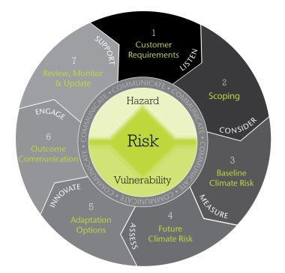
Step 1: Identify the needs, objectives and extent of the project, including the required outcomes and expectations
Step 2: Explore how available datasets can meet the key requirements
Step 3: Assess existing risks due to the current weather and climate
Step 4: Assess in detail how the key risks identified in step 3 are likely to change in the future
Step 5: Work with the customer to explore suitable adaptation options associated with the key risks
Step 6: Communicate clearly the project results and outcomes
Step 7: Review that the assessment has met the customer’s requirements, and identify future steps to be taken.

Steps 2, 3 & 4 (in blue above) require the input of weather and climate information, both past data and future projections.

The main parameters of interest are:
- Temperature
- Precipitation
Although, there are a number of other parameters (e.g. wind, humidity, pressure), which may be useful for particular impact assessments, and the Global Climate Observing System (GCOS) has defined a much wider set of Essential Climate Variables (ECVs) [3].

Gridded datasets in the form of time series or long term averages (e.g. 10 year & 30 year) with extremes and probabilities of exceeding threshold (of interest to the particular organisation/system) are most useful, as they provide the coverage required, and allow matching of past and future data. However, past observations may be useful for particular locations and the assessment of specific incidents.

Baselining the current climate risk requires past climate data, in the form of:
- Climatological observation records (e.g. Met Office Hadley Centre observations datasets [4])
- Gridded climatologies,
e.g. for the UK UKCP09 5km x 5km grids:
- Daily datasets (1960 to 2006)
- Metrics of precipitation
- Monthly datasets (currently updated to the end of 2005)
- Annual datasets (1961 to 2000)
- Baseline average datasets (1961 to 1990)
e.g. for Europe the ENSEMBLES daily gridded observational dataset (E-OBS RT5; 0.22 to 0.50 degrees resolution) from the European Climate Assessment & Dataset (ECA&D) [9]:
- Cloud cover
- Wind direction
- Wind speed
- Wind gusts
- Relative humidity
- Sea level pressure
- Precipitation amount
- Snow depth
- Sunshine
- Mean temperature
- Minimum temperature
- Maximum temperature
- Re-analyses, e.g.:
- ERA-Interim, ERA40 (ECMWF) [6]
- ACRE [7]
Below are examples of the E-OBS gridded climatology

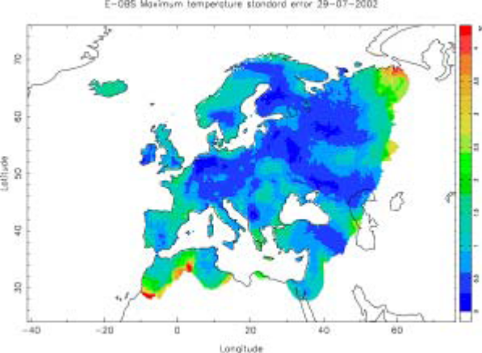
The future climate risk analysis requires Climate projections for various horizons out to 2100, including single and multi-model ensembles (with probabilities) and down-scaling using regional models. e.g.:
- UKCP09 [5], which are based on the Met Office Hadley Centre climate model HadCM3, using perturbed physics ensembles, with:
- Annual, seasonal and monthly climate averages.
- Individual 25 km grid squares, and for pre-defined aggregated areas.
- Seven 30 year time periods.
- Three emissions scenarios.
- Projections are based on change relative to a 1961–1990 baseline.
- WCRP CMIP3 multi-model dataset [8], which provides climate projections from a large number of groups in support of IPCC AR4.

(Seasonal and decadal forecasts are also useful tools to provide a full range of future predictions.)

The process identifies Risk Indicators (a measure of some quantity of interest to the customer, e.g. fire incidents per day), which are a function of the Hazard (e.g. fire) and the Vulnerability (e.g. population density). Note that Vulnerability here includes Exposure, which is sometimes treated separately.

The Hazard can be related to the climate variables (e.g. for fire incidents, it may be related to the number of days with the temperatures above a certain threshold and the precipitation below a certain threshold). This relationship may be given by an existing model, or past data provided by the customer can be used to define the relationship.

Vulnerability data may also be provided by the customer or by another competent authority (e.g. social scientists).

The baseline and future risks are usually shown as a raster plot against and appropriate map overlay, with time series at a location being used to shown variability over time (see examples below). Plots with ‘error bars’ and probability distribution functions may also be used to show the variability against a mean (either past or projected).

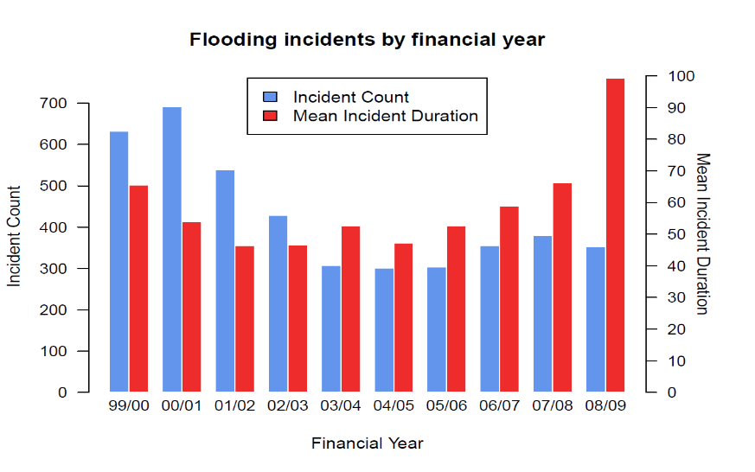

High Level Use Case
The Use Case diagram below shows all the use cases and actors considered. Use cases are colour-coded to indicate their focus.

Actors
- Climate Impacts Scientist – scientists involved in providing assessing climate impact and risk
- Customer – general class of actor used to describe a wide range of customers
- Other Competent Authority – some agency other than the customer qualified to provide information required for the impact and risk assessment
- Climatological Database – set of past weather and climate data available
- Climatological Observations Database – time series of point weather and climate observations
- Gridded Climatology Database – gridded datasets derived from observations
- Re-analysis Database – gridded datasets derived using an NWP model data assimilation scheme to analyse the observations
- Climate Projections Database – set of future climate projections using difference scenarios (this includes single and multi-model ensembles)
- Digital Map Management System (DMMS) – Database of map overlays at wide range of scales.

Detailed Structured Description of Climate Prediction Impact Use Cases
The climate impact use cases are presented in more detail using the standard template in the following sections.

Use Case 1: Explore how available datasets can meet the key requirements
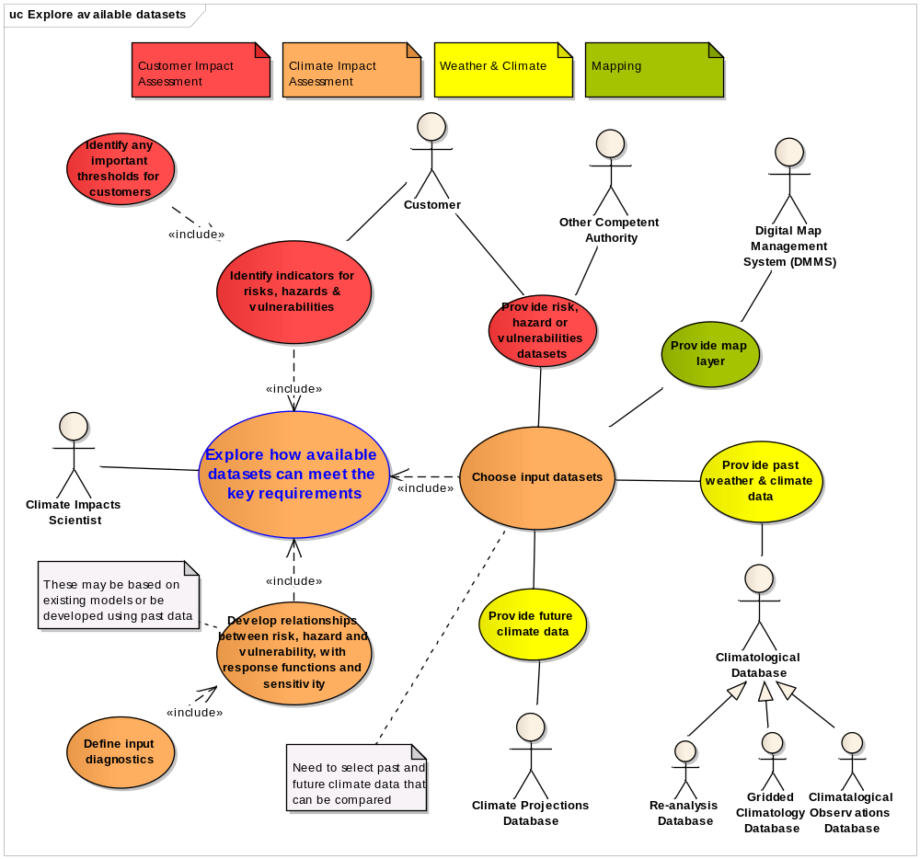

Use Case 1 | Explore how available datasets can meet the key requirements
Priority | High
Description | Climate Impact Scientist works with the customer to decide on the set of past weather & climate, future climate and other data should be used to assess the climate impact and risk for a particular customer. They also develop the relationships between the risk, hazard and vulnerabilities, with assessment of the response function and the sensitivity, using existing models or past data.
Pre-condition | Customer needs, objectives & extent of project, including the required outcomes & expectations, for the climate impact and risk assessment have been identified.
Flow of Events - Basic Path
Step 1 | Climate Impacts Scientist works with the Customer to identify the Risks, Hazards and Vulnerabilities Indicators of important to their area of concern.
Step 2 | Customer identifies and important threshold values.
Step 3 | Climate Impacts Scientist develops the relationship between the risk, hazard and vulnerabilities, including the response function and an assessment of the sensitivity.
Step 4 | Climate Impacts Scientist defines the input diagnostics required for the risk function (including the inputs to the hazard model)
Step 5 | Climate Impacts Scientist chooses the datasets to provide the input diagnostics for the risk function, and for the calibration of the hazard model, if required. This includes Past Weather & Climate Data (Climatological Observations, Gridded Climatologies, Re-analyses), Future Climate Projections and Risk, Hazard & Vulnerability Data
Post-condition | Identified set of input climate and vulnerabilities datasets and a calibrated hazard model.
Flow of Events - Alternative Path
Additional Step 6 |  | If necessary, the Climate Impacts Scientist develops the hazard model relationship with the input diagnostics.
Data Source: Risk, Hazards & Vulnerabilities Indicators
Description |  | Risk, hazard and vulnerabilities indicators of importance for the customer’s area of concern, including any important threshold values.
Data Provider |  | Customer
Geographic Scope |  | n/a
Thematic Scope |  | n/a
Scale, resolution |  | n/a
Delivery |  | Consultation
Documentation |  | None – dependent on customer
Data Source: Risk, Hazards & Vulnerabilities Datasets
Description | Various datasets characterising the risk, hazard and vulnerabilities of importance for the customers area of concern
Data Provider | Customer, Other Competent Authority
Geographic Scope | Area of interest (may be UK, regional or global)
Thematic Scope | Various (depending on customer area of concern)
Scale, resolution | Various, but likely to include PointSeries and GridSeries (spatial and temporal resolution depends on area of interest)
Delivery | Various
Documentation | None
Data Source: Climatological Observations
Description | Point weather and climate observations
Data Provider | Competent authorities in the weather and climate domain
Geographic Scope | Area of interest (potentially global)
Thematic Scope | Atmospheric Conditions (AC), Meteorological Geographic Features (MF)
Scale, resolution | PointSeries (typically daily max, min, mean or accumulation, but could be over various periods)
Delivery | Typically space-delimited text files as download
Documentation | e.g. http://www.hadobs.org/

Data Source: Gridded Climatologies for the Country of Interest
Description | Grids of climate parameters interpolated from observations
Data Provider | Competent authorities in the weather and climate domain
Geographic Scope | Country of interest
Thematic Scope | Atmospheric Conditions (AC), Meteorological Geographic Features (MF)
Scale, resolution | GridSeries (various, but for example for the UK: 5km, daily, monthly, annual and 30 year means)
Delivery | Typically space-delimited text or netCDF files as download
Documentation | e.g. http://www.metoffice.gov.uk/climatechange/science/monitoring/ukcp09/index.html
Data Source: Gridded Climatologies for Europe
Description | ENSEMBLES daily gridded observational dataset (E-OBS)
Data Provider | European Climate Assessment & Dataset (ECA&D)
Geographic Scope | Europe
Thematic Scope | Atmospheric Conditions (AC), Meteorological Geographic Features (MF)
Scale, resolution | GridSeries (0.22 – 0.50 degrees, daily 1950 – present)
Delivery | netCDF
Documentation | http://eca.knmi.nl/download/ensembles/ensembles.php
Data Source: Re-analyses
Description | Grids derived using an NWP model data assimilation scheme to analyse the observations
Data Provider | Competent authorities in the weather and climate domain
Geographic Scope | Global
Thematic Scope | Atmospheric Conditions (AC), Meteorological Geographic Features (MF)
Scale, resolution | GridSeries (various spatial & temporal resolutions)
Delivery | Typically netCDF file download
Documentation | e.g. http://www.ecmwf.int/research/era/do/get/Reanalysis_ECMWF
Data Source: Future Climate Projections
Description | Set of gridded data of future climate projections using difference scenarios (this includes single and multi-model ensembles)
Data Provider | Competent authorities in the weather and climate domain
Geographic Scope | Global
Thematic Scope | Atmospheric Conditions (AC), Meteorological Geographic Features (MF)
Scale, resolution | GridSeries (various spatial & temporal resolutions)
Delivery | Typically netCDF file download
Documentation | e.g. http://www-pcmdi.llnl.gov/ipcc/about_ipcc.php
Data Source: Map
Description |  | Geographical map at appropriate scale
Data Provider |  | Various
Geographic Scope |  | Area of interest, potentially anywhere on the globe
Thematic Scope |  | Cadastral Parcels (CP)?
Scale, resolution |  | Polygons provided as raster image
Delivery |  | As part of visualisation of other data
Documentation |  | None

Use Case 2: Assess existing risks due to the current weather & climate
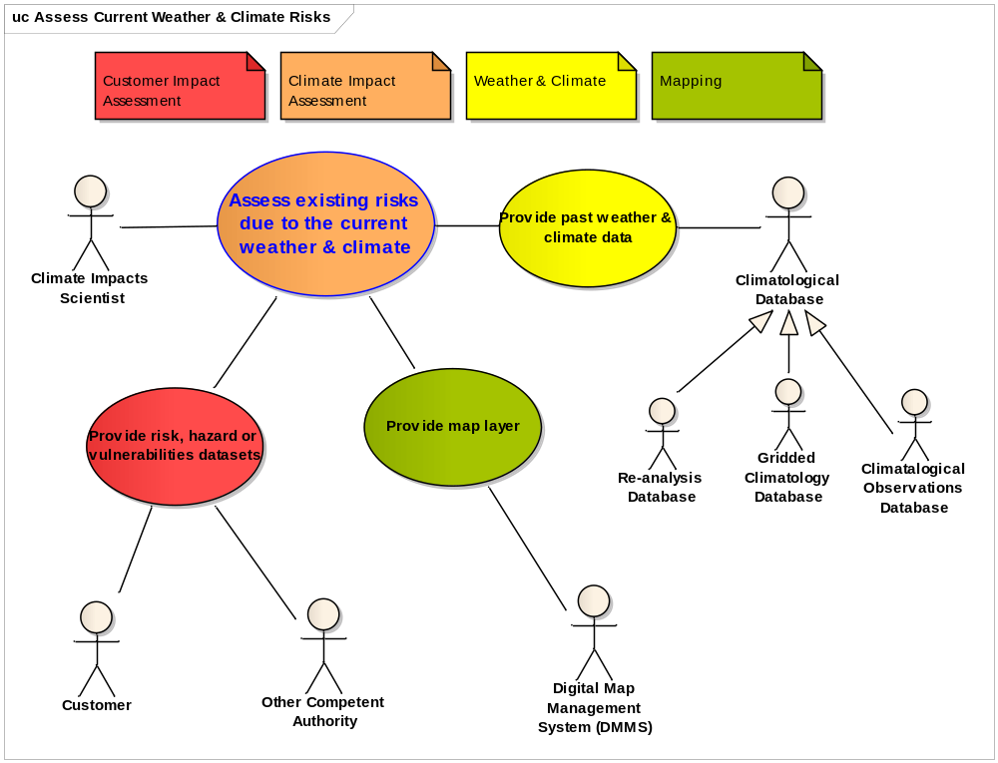

Use Case 2 | Assess existing risks due to the current weather & climate
Priority | High
Description | Climate Impacts Scientist assesses the current customer expose to climate impacts and risks using past climate and weather data. They also calibrate/baseline the risk function relationship.
Pre-condition | Identified set of input climate and vulnerabilities datasets and a calibrated hazard model.
Flow of Events - Basic Path
Step 1 | Climate Impacts Scientist uses the Past Weather & Climate Data (Climatological Observations, Gridded Climatologies, Re-analyses) and Risk, Hazard & Vulnerability Data within the risk function and hazard model relationships to assess the current exposure (and calibrate/baseline the relationships) to climate and weather.
Step 2 | Climate Impacts Scientist reviews the results using various Visualisations of Risk Indicators
Post-condition | Current (baseline) risk understood. Risk function calibrated.
Flow of Events - Alternative Path
Additional Step 1a |  | If relevant the Climate Impacts Scientist may use Climatological Observations with the Risk, Hazard & Vulnerability Data to investigate specific events to gain further insight to the hazard model relationship with the input diagnostics.
Data Source: Climatological Observations (as per Use Case 1)
Data Source: Gridded Climatologies (as per Use Case 1)
Data Source: Re-analyses (as per Use Case 1)
Data Source: Risk, Hazards & Vulnerabilities Data (as per Use Case 1)
Data Source: Visualisations of Risk Indicators
Description | Visualisation of risk indicators, as maps (usually filled gridboxes), time series (possibly with error/range bars) or probability distribution functions (PDFs).
Data Provider | Met Office
Geographic Scope | Area of interest (may be UK, regional or global)
Thematic Scope | Atmospheric Conditions (AC), Meteorological Geographic Features (MF) and various others (depending on customer area of concern)
Scale, resolution | Grid, Point , PointSeries (spatial and temporal resolution depends on area of interest)
Delivery | GIS tool, webpage or as part of a report
Documentation | None
Data Source: Map (as per Use Case 1)

Use Case 3: Assess in detail how the key risks identified are likely to change in the future

Use Case 3 | Assess in detail how the key risks identified are likely to change in the future
Priority | High
Description | Climate Impact Scientists assesses the future customer expose to climate impacts and risks using climate projections.
Pre-condition | Current (baseline) risk understood. Risk function calibrated.
Flow of Events - Basic Path
Step 1 | Climate Impacts Scientist uses the Future Climate Projections and Risk, Hazard & Vulnerability Data within the risk function and hazard model relationships to assess the exposure to future changes in climate and weather.
Step 2 | Climate Impacts Scientist reviews the results using various Visualisations of Risk Indicators
Post-condition | Future risk understood.
Data Source: Future Climate Projection (as per Use Case 1)
Data Source: Risk, Hazards & Vulnerabilities Data (as per Use Case 1)
Data Source: Visualisations of Risk Indicators (as per Use Case 2)
Data Source: Map (as per Use Case 1)

References
- Joint UK Land Environment Simulator (JULES): http://www.metoffice.gov.uk/research/collaboration/jwcrp/jules
- Prepare: Understand your weather and climate related risks (Climate Impacts and Risk assessment Framework (CIRF) Data Sheet): http://www.metoffice.gov.uk/publicsector/cirf-datasheet.pdf
- Essential Climate Variables (ECV) Data Access Matrix (GCOS): http://gosic.org/ios/MATRICES/ECV/ecv-matrix.htm
- Met Office Hadley Centre observations datasets: http://www.hadobs.org/
- UK Climate Projections (UKCP09): http://ukclimateprojections.defra.gov.uk/content/view/868/531/
- Reanalysis at ECMWF (ERA): http://www.ecmwf.int/research/era/do/get/Reanalysis_ECMWF
- Atmospheric Circulation Reconstructions over the Earth (ACRE): http://www.met-acre.org/
- WCRP CMIP3 multi-model dataset (IPCC AR4): http://www-pcmdi.llnl.gov/ipcc/about_ipcc.php
- European Climate Assessment and Dataset (ECA&D): http://eca.knmi.nl/

Annex 1: Definition of terms

Term | Definition
Risk | Risk is a function of the weather or climate hazard and vulnerability of the system, or more simply: Risk = Hazard x Vulnerability. With regard to climate change, it combines the magnitude of the impact with the probability of it occurring, accounting for uncertainty in climate system, exposure to the hazard, underlying social and economic vulnerability, and capacity to adapt. (adapted from Taubenbock 2008 and IPCC AR4 WGII)
Hazard | The magnitude and frequency of a hazardous weather or climate event (adapted from Taubenbock 2008). Assessments of the future climate hazard also include a measure of the probability of the outcome occurring (this is analogous to "uncertainty")
Probability | A numerical measure of the state of knowledge, degree of belief, state of confidence, or uncertainty of, a climate outcome. (adapted from Kaplan and Garrick, 1980)
Vulnerability | The inter-relation of exposure and susceptibility as stressor of the system, altered by the ability of the system to adapt to changes (adapted from Taubenbock 2008). Vulnerability = Susceptibility x Exposure / Adaptive capacity. Vulnerability can be measured by physical, demographic, social, economic, environmental and political factors which affect the system's ability to respond to the impacts of the hazard.
Exposure | The degree, duration and/or extent to which a system is in contact with the hazard. Exposure often equates to location factors; for example, a house built on a flood plain is more vulnerable than a house that is not because of it is exposed to the flood hazard (adapted from Taubenbock 2008)
Susceptibility | The capacity of individuals, groups or the physical or socioeconomic system to withstand the impact of the hazard (adapted from Taubenbock 2008)
Adaptive capacity | The ability to cope with or adapt to hazard stress. It is the product of planned preparation, spontaneous adjustment and relief and reconstruction (adapted from Taubenbock 2008)
CIRF | The Climate Impacts and Risk assessment Framework, or CIRF, describes the process of doing a risk assessment for an organisation or system. It is intended as a guide, which can be shown to the customer as a visual guide to the process, or equally can be used in conjunction with the advice below to guide the scientist doing the work. Pronounced as "serf".

World Climate Research Programme
Phase 3 of the Coupled Model Intercomparison Project
Projections against various emissions scenarios
Fourth Assessment Report of the Intergovernmental Panel on Climate Change

