RGS Interoperability Experiment – Australian scenario overview
This document gives an overview of the potential exchange scenario between the Bureau of Meteorology, Murray-Darling Basin Authority, NSW Office of Water, and the Tasmanian Department of Primary Industries, Parks, Water and Environment (DPIPWE) – the data holding agencies. These agencies make use of the Kisters’ Hydstra product and the Aquatic Informatics’ Aquarius product.

Figure 1 shows the basic structure of the scenario. The top layer shows the water agencies providing data through standard web services, with multiple consumers shown along the bottom.
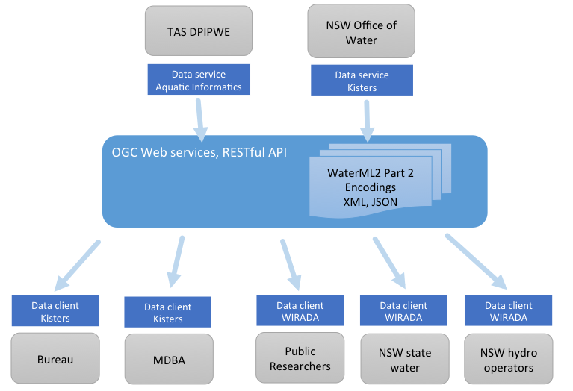
Figure 1 - basic exchange scenario
The web services will use an agreed on API that will respond to requests for particular rating tables and metadata. This will encode documents that conform to a version of the WaterML2.0 part 2 information model. The exact nature of the API and encoding format has not yet been agreed -- this is part of the planning of the IE. Participants are encouraged to get involved in this process.

Data scope
For the purposes of the IE, the data holding agencies may select an appropriate subset of their available sites to expose rating tables. This should be done in the planning of the IE to align a useful domain scenario that fits with the interests of the exchanging partners.

Software
In order for data holding agencies to serve up the required data, the underlying systems need to implement the specified API(s). The effort required for this development will vary based on the underlying architecture of the system, including:
- How available are programmable interfaces to pull out the data from internal storage?
- How easily can the underlying software be extended to support a new web service?
- How easily is it for a prototype/non-approved software to be deployed into he data holding agencies?
- How much security and/or anonymity of data is required?
These are questions that are mostly out of control of the IE, but will greatly affect its viability and timeline. We therefore encourage participants to assess the viability of such a setup. We will schedule discussions with participants to go through the options.

Web client for data analysis
A web-based visualization and analysis scenario will operate across most of the exchange scenarios. This will involve exploration of the data exposed by the web services. The basic use case is to view the available rating tables for given sites; plot their associated gaugings, and display relevant statistics/metadata. An example of how this client may work is shown in this video: https://vimeo.com/70310422. This client requires access to both rating tables and gauging data through a web accessible API.

Web services for use within the IE
There are a number of options that will be explored for the web-service API; from existing OGC services such as WFS and SOS, to custom RESTful services to suit the domain model. The primary goal of the interoperability experiment is to test the capability of the information in the expression of the domain concepts; the use of this model with OGC web services is a secondary aspect. It may only be practical for participants to implement a web service that is more aligned with their existing software, so some flexibility can be incorporated into the experiment.
The web client described has implemented a simple REST-based API for demo purposes, which uses a JSON response encoding. This API will require further work, but it provides an example of the core requirements and is included at the end of this document for informational purposes. An XML/GML format will also be used.

http://www.opengeospatial.org/standards/wfs
http://www.opengeospatial.org/standards/sos

